RESEARCH IN CONTEXT: Seed ecology of European mesic meadows

Eduardo Fernández-Pascual1,2 +, Madalena Vaz3, Beatriz Morais2, Ramón Reiné4, Joaquín Ascaso4, Elías Afif Khouri5, Angelino Carta6

1 IMIB – Biodiversity Research Institute, University of Oviedo, Mieres, Spain; 2 Departamento de Biología de Organismos y Sistemas, Universidad de Oviedo, Oviedo/Uviéu, Spain; 3 Banco Português de Germoplasma Vegetal, Instituto Nacional de Investigação Agrária e Veterinária (INIAV), Braga, Portugal; 4 Departamento de Ciencias Agrarias y Medio Natural, Universidad de Zaragoza, Huesca, Spain; 5 Agroforestry Engineering Area, Department of Organisms and Systems Biology, Polytechnic School of Mieres, University of Oviedo, 33600 Mieres, Asturias, Spain; 6 Dipartimento di Biologia, Botany Unit, University of Pisa, Pisa, Italy

Running title: Seed ecology of European mesic meadows

+ Correspondence: IMIB – Biodiversity Research Institute, University of Oviedo, Edificio de Investigación – 5ª planta, C/ Gonzalo Gutiérrez Quirós s/n 33600 Mieres, Spain. Email: [fernandezpeduardo@uniovi.es](mailto:fernandezpeduardo@uniovi.es). Telephone: +34 985103000.

# ABSTRACT (300 words)

* **Background and Aims** European mesic meadows are semi-natural open habitats of high biodiversity and an essential part of European landscapes. These species-rich communities can be a source of seed mixes for ecological restoration, urban greening and rewilding. However, limited knowledge of species germination traits is a bottleneck to the development of a competitive native seed industry. Here, we synthesize the seed ecology of mesic meadows.
* **Methods** We combined our own experimental data with data obtained from databases to create a combined dataset containing 2,005 germination records of 90 plant species from 31 European countries. We performed a Bayesian meta-analysis of this dataset to test the seed germination response to environmental cues including scarification, stratification, temperature, alternating temperature and light. We also used multivariate ordination to check the relationship between seed traits (germination and morphology) and species ecological preferences, and to compare the seed ecology of mesic meadows with that of other herbaceous plant communities from the same area.
* **Key Results** The seed ecology of mesic meadows is characterized by (1) high seed germinability when compared to other herbaceous plant communities; (2) low correspondence between seed traits and species ecological preferences; and (3) a deep phylogenetic separation between the two major families, Poaceae and Fabaceae. Poaceae produce many light seeds which respond to gap-detecting germination cues (alternating temperatures and light); Fabaceae produce fewer heavy seeds, which need scarification to break their physical dormancy.
* **Conclusions** High germinability of meadow seeds will reduce their capacity to form persistent seed banks, resulting in dispersal limitations to passive regeneration. For centuries, human activities have shaped the regeneration of meadows, leading to a loss of seed dormancy and decoupling seeds from seasonal cycles, as has been found in many domesticated species. The same anthropic processes that have shaped semi-natural mesic meadows have left them dependent on continued human intervention for their regeneration, highlighting the importance of active restoration via seed supply.

# KEYWORDS

*Arrhenatheretalia*, *Arrhenatherion*, Asteraceae, Fabaceae, domestication, hay meadows, mesic grasslands, Poaceae, seed germination, seed morphology, semi-natural, species-rich meadows

# INTRODUCTION

The mesic meadows of Europe are semi-natural open habitats that occupy clearings created by human intervention over a temperate wooded landscape (Poschlod *et al.* 2009; Hejcman *et al.* 2013), in sites with moderately fertile and well-drained soils (Mucina *et al.* 2016). These novel anthropogenic plant communities, with a composite flora made up of species from different ecological backgrounds, have constantly changed in response to shifts in human society and associated management practices (Chytrý 2012; Hejcman *et al.* 2013), but nonetheless characterise Europe’s natural history (Finck *et al.* 2002).

Traditional classification of mesic grasslands emphasises the separation between meadows used for hay making versus pastures maintained by grazing, but a recent revision at the European level showed that the main driver of variation in species composition is the intensity rather than the type of management (Rodríguez-Rojo *et al.* 2017). Indeed, changes in the intensity of management, including land abandonment and agricultural intensification, are threatening the maintenance of mesic meadows in large parts of Europe (Carboni *et al.* 2015). For this reason, the European Habitats Directive (92/43/EEC) lists as habitats of conservation interest those species-rich meadows that are traditionally managed by one or two annual cuts and light grazing.

One of the reasons for the high conservation interest of traditional mesic meadows is their high species richness, and for this same reason they have been highlighted as a valuable source of natural seed material to be used in ecological restoration, rewilding and urban greening (Krautzer *et al.* 2013; Haslgrübler *et al.* 2014; Golińska *et al.* 2017). However, a lack of knowledge about species germination traits has already been identified as a bottleneck (Ladouceur *et al.* 2018) hampering the development of a competitive native seed industry (De Vitis *et al.* 2017) in Europe. Understanding seed germination is part of the practical scientific framework needed to tackle large-scale ecological restoration challenges (Merritt and Dixon 2011) and to maintain *ex situ* collections of plant genetic resources (Li and Pritchard 2009). When such knowledge is available, ambitious regional schemes of seed-based landscape restoration can be designed (Jiménez-Alfaro *et al.* 2020).

Mesic meadows are dominated by mesophilous grasses of the family Poaceae, which make up most of the biomass in the community and define the structure of the vegetation. The dispersal unit in Poaceae is generally the floret (**Fig. 1a**), a composite structure made up of the caryopsis or grain (a dry, indehiscent and monospermic fruit) and its surrounding bracts (i.e. modified leaves): the lemma and the palea. Removal of the lemma and palea, as well as puncturing the pericarp, can aid in seed germination (Probert *et al.* 1985). The dispersal unit often carries awns or hairs (**Fig. 1b**) that are assumed to aid dispersal, although it is not always the case that they do (Schonfeld and Chancellor 1983). Several genera of Poaceae that grow in European meadows show seed heteromorphism (see e.g. *Aegilops*, *Avena*, *Dasypirum*, *Poa*) (Guzzon *et al.* 2018). They produce different seed morphs characterized by different seed traits in terms of dormancy, longevity, morphology, phenology, tolerance to abiotic stresses and susceptibility to predation. This is connected to bet hedging ecological strategies, typical of ruderal/disturbed habitats. Regarding germination, meadow Poaceae seeds have been reported as having physiological seed dormancy in various degrees (Sprague 1940; Dixon 1995; Baskin and Baskin 2014), but germinability is usually high even without treating the seeds with cold stratification (Grime *et al.* 1981; Schonfeld and Chancellor 1983; Williams 1983a; Bean *et al.* 1984; Froud-Williams *et al.* 1984, 1986; Froud-Williams and Ferris 1987; Dixon 1995; Pérez-Fernández and Rodríguez-Echeverría 2003; Pérez-Fernández *et al.* 2006; Stanisavljevic *et al.* 2011, 2015; Oliveira *et al.* 2012; Wille *et al.* 2013). Freshly harvested seeds are comparatively more dormant than stored seeds, but dormancy tends to disappear quickly in dry storage (Sprague 1940; Dixon 1995). Germination has been reported to occur at temperatures ranging from 5 to 30 ºC (Grime *et al.* 1981; Williams 1983b; Pannangpetch and Bean 1984; Froud-Williams *et al.* 1986; Probert *et al.* 1986; Dixon 1995). Most Poaceae species have also been reported to germinate better in light than in darkness (Williams 1983b; c; Froud-Williams *et al.* 1984; Probert *et al.* 1985, 1986; Probert and Smith 1986; Thompson 1989; Dixon 1995) and even to be unable to germinate in darkness (Froud-Williams *et al.* 1986). Nonetheless, species of *Bromus* have been reported as germinating better in darkness (Thompson 1989) and *Cynosurus cristatus* as being indifferent to light/darkness (Williams 1983b; c). In *Poa trivialis*, germination is promoted by light but not by diurnal alternating temperatures (i.e. germination conditions where different temperatures are applied during the day and the night, in diurnal cycles) (Froud-Williams and Ferris 1987), although alternating temperatures do encourage some germination in darkness (Froud-Williams *et al.* 1986). Wild Poaceae ecotypes usually have a germination response to alternating temperatures (Schonfeld and Chancellor 1983; Williams 1983b; c; Pannangpetch and Bean 1984; Probert *et al.* 1985, 1986; Probert and Smith 1986; Thompson 1989), although this response is missing in some wild ecotypes and in the domesticated cultivars (Pannangpetch and Bean 1984), and some species such as *Lolium perenne* have been reported as insensitive to temperature alternation (Thompson *et al.* 1977; Williams 1983c).

Next in abundance to Poaceae are the legumes of the family Fabaceae. Fabaceae species contribute to the nutritional value of meadow fodder, as thanks to their N-fixating capabilities they have high N contents (Reiné *et al.* 2020; Álvarez *et al.* 2021). The dispersal unit of most Fabaceae is the seed itself (**Fig. 1c**) but in some species dispersal units are more complex, including indehiscent monospermic fruits (e.g. *Onobrychis*, **Fig. 1d**) or indehiscent monospermic fruit fragments, i.e. loments (e.g. *Ornithopus*, **Fig. 1e**). Fabaceae are generally hard-seeded: they have a water-impermeable seed coat which needs to become permeable before germination can happen (i.e. physical seed dormancy) (Grime *et al.* 1981; Jones and Turkington 1986; Ehrman and Cocks 1996; Kupferschmid *et al.* 2000; Baskin and Baskin 2014). In *Medicago*, seeds that have not reached full maturity can germinate before they become impermeable, but the completion of maturation imposes coat impermeability, and thereafter the seed must be scarified to allow water imbibition and germination (Gresta *et al.* 2007). Buried Fabaceae seeds can track the seasons, and in some species, germination seems to be promoted by cold stratification and alternating temperatures (Van Assche *et al.* 2003); some of these species have been described as having combinational dormancy (i.e. physical + physiological) (Van Assche and Vandelook 2010). However, Fabaceae seeds have also been reported to germinate without any previous treatment (Marchiol *et al.* 2000; Nikolic *et al.* 2007; Kabouw *et al.* 2010; Oliveira *et al.* 2012), and to lose dormancy during storage (Van Assche and Vandelook 2010). As in Poaceae, seeds of Fabaceae have been reported to germinate in high numbers across a range of temperatures from 5 to 25 ºC (Grime *et al.* 1981; Gresta *et al.* 2007). Fabaceae seeds have been described as not being responsive to light and as capable of germinating in darkness (Silvertown 1980; Grime *et al.* 1981).

Poaceae and Fabaceae are accompanied by a diversity of other families which, even if present in lower abundances, contribute to the high biodiversity of the system and increase the aesthetic value of the meadows as perceived by people (Southon *et al.* 2017; Chollet *et al.* 2018). They also add nutritional scope for livestock, being richer than Poaceae and Fabaceae in specific elements (Reiné *et al.* 2020; Álvarez *et al.* 2021). In many of these families (e.g. Asteraceae, Cyperaceae, Dipsacaceae, Lamiaceae, Polygonaceae, Ranunculaceae) the dispersal unit is the achene: dry, indehiscent and monospermic fruits. The morphology of these achenes is varied: cypselae with a hairy pappus in *Centaurea* (Asteraceae, **Fig. 1f**); beaked in *Ranunculus* (Ranunculaceae, **Fig. 1g**); hardened nutlets in *Prunella* (Lamiaceae, **Fig. 1h**); hairy and with an elaiosome in *Knautia* (Dipsacaceae, **Fig. 1i**); surrounded by a perigynium which aids in dispersal by water in *Carex* (Cyperaceae, **Fig. 1j**). In the genus *Sanguisorba* (Rosaceae), the dispersal unit is the urn-shaped receptacle containing one to three achenes (**Fig. 1k**). In Apiaceae, it is the mericarp (**Fig. 1l**), an indehiscent monospermic fragment of the fruit. In some other minor families, the dispersal unit is the seed itself, such as in Caryophyllaceae (**Fig. 1m**), Plantaginaceae (**Fig. 1n**), Juncaceae or the hemiparasitic species of *Rhinanthus* (Orobanchaceae) (**Fig. 1o**). In Asteraceae, high germination without previous treatments has been reported in *Taraxacum officinale* (Mezynski and Cole 1974; Washitani 1984; Noronha 1997; Benvenuti and Pardossi 2016; Masin *et al.* 2017), *Hypochaeris radicata* (Oomes and Elberse 1976; Benvenuti and Pardossi 2016) and *Achillea millefolium* (Oomes and Elberse 1976). *Taraxacum officinale* germinates between 5 and 30 ºC (Mezynski and Cole 1974; Washitani 1984; Masin *et al.* 2017) and has higher germination in light (Thompson 1989; Letchamo and Gosselin 1996; Noronha 1997) and in alternating temperatures (Mezynski and Cole 1974). In *Stachys officinalis* (Lamiaceae), seeds need either cold stratification, light or alternating temperatures to germinate (Wagner *et al.* 2011; Kolodziejek *et al.* 2017). Underdeveloped embryos that need to grow inside the seed before germination (i.e. morphological dormancy) are widespread in Ranunculaceae and Apiaceae (Jauzein and Mansour 1992; Baskin and Baskin 2014). *Ranunculus repens* (Ranunculaceae) germinates between 10 and 25 ºC, but the germination percentages have been reported to be low (Harris *et al.* 1998); the same species has been reported to respond to alternating temperatures, which can promote its germination even in darkness (Thompson and Grime 1983). In Polygonaceae, *Rumex acetosa* can germinate immediately after dispersal and between 7 and 27 ºC, while the congeneric *Rumex acetosella* does not: this difference is due to the former being able to germinate at constant temperatures in the darkness (Grime *et al.* 1981; Van Assche *et al.* 2002), while the latter has an absolute requirement for light (Van Assche *et al.* 2002). In *Heracleum sphondylium* (Apiaceae), growth of the embryo only occurs below 10 ºC, in moist conditions (Jauzein and Mansour 1992). *Sanguisorba minor* (Rosaceae) increases its germination after abrasion of the seeds with bleach (Tavşanoğlu *et al.* 2015; Benvenuti and Pardossi 2016), although germination without previous treatment has also been reported (Ludewig *et al.* 2014; Tavşanoğlu *et al.* 2015). Seeds of the hemiparasitic species *Rhinanthus angustifolius* and *Rhinanthus minor* (Orobanchaceae) require relatively long periods of cold stratification to germinate (Ter Borg 2005) and can germinate in the dark (Marin *et al.* 2019).

Although a wealth of studies has accumulated, a synthesis of the seed ecology of European mesic meadows is still missing. In this article, we review for the first time this topic to provide an overview of traits related to plant regeneration by seed, as a knowledge basis to expand our understanding of meadow communities and assist in their management by conservation and restoration practitioners. We combine newly generated data on seed morphology and germination with records from existing databases (Kleyer *et al.* 2008; Royal Botanic Gardens, Kew 2017; Fernández-Pascual 2021). The resulting dataset contains 2,005 germination records of 90 plant species from 31 European countries. We use this dataset to test the seed germination response to environmental cues including scarification, stratification, temperature, alternating temperature and light, applying Bayesian meta-analysis (Pappalardo *et al.* 2020). Further, using well-preserved meadows of the Iberian Peninsula as a study system, we analyse the covariation between seed traits and species environmental preferences, and compare the germination ecology of mesic meadows with that of other herbaceous plant communities from the same geographic area.

# MATERIALS AND METHODS

## Data sources

### Selection of mesic meadow species

To create a list of representative European mesic meadow species for inclusion in our analysis, we used the list of species provided by Chytrý et al. (2020) as dominant, constant and diagnostic species of the EUNIS habitats “low and medium altitude hay meadows” and “mountain hay meadows.” This list included 120 species and was used to test the response to germination cues at the European level (see below).

To conduct further analyses at the Iberian level, we constructed a second species list based on a dataset comprising 118 vegetation relevés (i.e. records of plants species co-occurring in sampling plots) from three Iberian regions with well-maintained mesic meadows: 43 relevés from Northern Portugal, 25 from the Cantabrian Mountains of Spain and 50 from the Pyrenees. These relevés were used to assess variation in seed responses along environmental gradients (i.e. the relationship between species seed traits and species ecological requirements, see below), as they were recorded along a major stress gradient related to summer drought (Rodríguez-Rojo *et al.* 2014): the Pyrenees and Cantabrian Mountains have a temperate macroclimate, whereas Northern Portugal is transitional between the temperate and Mediterranean macroclimates. Furthermore, meadows from the Pyrenees are closest to the European optimum of mesic meadow vegetation while the Portuguese ones are in suboptimal areas at the limit of the European distribution of temperate meadows (Rodríguez-Rojo *et al.* 2017). Finally, the traditional management of meadows (i.e. mowing for haymaking once or twice per year plus light grazing) is relatively well preserved in these three regions compared to their European context (Prince *et al.* 2012; Guadilla-Sáez *et al.* 2019).

The Iberian meadows were maintained by traditional agricultural practices: mowing for haymaking once or twice per year plus light grazing. Each vegetation sampling plot was placed in a square area (25-100 m2 area) situated in the central part of the meadow, avoiding the margins. Vegetation sampling took place in 2016-2017, at the peak of plant development, just before mowing. All vascular plant species in the plots were recorded and given a cover value using the transformation of the Braun-Blanquet scale to coverage (+ = 0.1%, 1 = 5%, 2 = 17.5%, 3 = 37.5%, 4 = 62.5% and 5 = 87.5%). All plant names were assigned following the nomenclature of Euro+Med (2006), which is used throughout this article. As expected, the vegetation of the sampled meadows was dominated by Poaceae and Fabaceae: these two families represented 47% and 17%, respectively, of the total plant cover recorded in all the plots. Other 20 families were recorded, the largest of which was Asteraceae; each of these other families represented less than 10% of the total cover.

Using all the relevés, we calculated the cumulative cover of each species in the entire area. To perform the calculation, first we standardized the cover values of the plots by dividing the cover of each species in each plot by the total plant cover in that plot. Then, for each species, we calculated its total cover in the dataset, by summing its standardized cover values from all the plots. Finally, we rescaled the values of all species to a 1-100 scale to obtain the cumulative cover values. From the resulting list of species, we removed 208 species with cumulative cover values below 2%, considering them to be transient species (Mariotte 2014) that might have been recorded by chance and may not represent the core mesic meadows flora. We used the remaining 116 species as the core list of Iberian meadow species. Most of these species were hemicryptophytes (78%), with some therophytes (16%) and a few chamaephytes and geophytes (3% of each). The family with more species in the list was Poaceae (22%), with another 17% belonging to Fabaceae, 15% to Asteraceae, 8% to Apiaceae, and the rest of the families representing less than 5% each.

### Species ecological requirements

We also used the Iberian relevés as a basis to characterize the preferences of the selected species for three environmental factors (cold, summer drought and soil reaction) which have been found to be major ecological drivers of mesic meadow plant diversity (Rodríguez-Rojo *et al.* 2014). For cold and drought, we used the coordinates of the plots to retrieve from CHELSA (Karger *et al.* 2017) the bioclimatic variables bio06 (minimum temperature of the coldest month) and bio14 (precipitation of the driest month). For soil reaction (pH), we took from each plot five soil samples from between 0 and 20 cm depth with a Dutch auger and combined them to make a bulk soil horizon, which we subsequently air-dried, crumbled, finely crushed and sieved with a 2 mm screen, to finally measure the pH in H2O with a glass electrode in a suspension of soil:water (1:2.5). With each of these three environmental variables (bio06, bio14, pH) measured at the plot level we calculated the species niche centroids (SNCs). The SNC for any given species and variable is the mean of the environmental variable in all the plots where the species occurs, weighted by species cover in each plot (Zelený 2018).

### Seed morphology

From the vegetation plots described above, we collected dispersal units (hereafter called seeds) during the dispersal seasons of 2016, 2017 and 2018. Seed collection followed the methodology of ENSCONET (2009). To describe seed morphology, we acquired images of 100-seed samples of each species using a flatbed scanner (Brother LC985) with a resolution of 200 dpi and a scanning area of 1024 x 1024 pixels (Bacchetta *et al.* 2008). We distributed the seeds on the transparent glass of the scanner, in a 10 x 10 grid. For each sample, and without moving the seeds, we repeated the scan with black and white backgrounds. In the case of the black background, we covered samples with a black box to avoid interference from environmental light. For the white background, we used the scanner cover. We digitized the obtained images and stored them in JPEG format (Joint Photographic Experts Group). We processed the scanned images using *ImageJ*, an open-source image processing program designed for scientific multidimensional images (Schneider *et al.* 2012). The program calculates several biometric parameters for each seed on the sample, and among those we chose seed length and width. Additionally, we retrieved species values of seed mass from the Seed Information Database (Royal Botanic Gardens, Kew 2017) and of seed number at the individual/ramet level from the LEDA database (Kleyer *et al.* 2008). The dataset with the length and width measures is available at GitHub (see Data Availability Statement).

### Seed germination

We constructed a germination dataset by combining the results of our own germination experiments with Iberian seeds, and records of seed germination of meadow seeds from across Europe.

We germinated the collected Iberian seeds using three germination treatments to determine the germination response to temperatures that are representative of the study area: 14/4 ºC representing the capacity of freshly-dispersed seeds to germinate at cool temperatures of spring and autumn, 22/12 ºC as summer temperature, and 30/20 ºC as sun-heated soil, e.g. soil exposed to sun after hay cutting. Additionally, we compared, for each of these temperature regimes, the germination of fresh seeds versus seeds subjected to a dormancy-breaking treatment. This treatment was adjusted to the most probable dormancy type per taxonomic group (Baskin and Baskin 2014). In the case of Fabaceae and other families that might present physical dormancy (Baskin and Baskin 2014), the treatment consisted in scarification by chipping the seed coat with a scalpel. For the rest of the families, we used gibberellic acid GA3 (0.0645 mM) in darkness during 24h, as a treatment to remove potential physiological seed dormancy (Blandino *et al.* 2019). For each species and treatment, we sowed four Petri dishes with 25 seeds each. The germination substrate was 1% distilled water - agar. We sealed dishes with Parafilm to prevent desiccation. Trials took place in a germination chamber (KBW 400, Binder GmbH, Tuttlingen, Germany) with a 12/12-hour photoperiod (the light period corresponding to the higher temperature). Experiments lasted for four weeks, with germination scoring once per week. The germination criterion was 2 mm radicle emergence. After four weeks, we cut the seeds that failed to germinate and examined them under a magnifying glass. We classified them as normal when the embryo was visible and firm, empty when they lacked an embryo, and contaminated when they were mouldy. We only considered normal seeds when calculating germination proportions and conducting subsequent analyses.

In addition to this experimental germination data, we retrieved European seed germination records for the European list of study species from ENSCOBASE, the seed germination database of the European Native Seed Conservation Network (<http://enscobase.maich.gr/index.tml>); and the *SylvanSeeds* database of seed germination records for the nemoral biome (Fernández-Pascual 2021). These new records included additional records of species in our experimental dataset, plus records of new species absent from our experimental dataset, and in all cases corresponded to seed lots originally collected within Europe. The combined dataset, including our own experimental data and the records from ENSCOBASE and *SylvanSeeds*, contained 90 species (i.e. 90% of the core list of meadow species was covered) and 2,005 germination records (i.e. germination proportions for a given seed lot of a species, recorded in a set of laboratory experimental conditions) from 31 European countries. Overall, 156,252 seeds had been used in the experiments. The range of experimental germination temperatures (weighted average of the daily thermoperiod) which had been used in the experiments spanned from 2 to 31 ºC, with 1,226 records of constant temperatures (i.e. experiments that used the same temperature during all their duration) and 779 of alternating temperatures (i.e. experiments where different temperatures were applied during the day and the night, in diurnal cycles). Seeds had been exposed to light during some part of the diurnal cycle in 1,907 records or kept in total darkness in 98 records. Experiments had been performed with unstratified seeds (i.e. not subjected to a previous dormancy-breaking incubation) in 1,726 records and with stratified seeds (i.e. subjected to previous incubation in dormancy-breaking conditions, including treatments of wet incubation under cold, warm and combinations of cold and warm conditions) in 279 records. There were 262 records where GA3 had been applied, and 369 records where seeds had been scarified.

Finally, to compare the germination of mesic meadow species with that of other herbaceous communities, we retrieved data from previous works on the seed germination ecology of bogs and fens (Fernández-Pascual *et al.* 2013; Fernández-Pascual 2016), alpine and subalpine grasslands (Fernández-Pascual, Jiménez-Alfaro, *et al.* 2017), and coastal plant communities of rocky cliffs and sand dunes (Fernández-Pascual, Pérez-Arcoiza, *et al.* 2017). These additional germination records had been obtained using the same experimental methodology as the one employed for some of the germination experiments of this study: recently collected seeds, untreated for physiological dormancy (but scarified in the cases of families known for having physical dormancy), had been subjected to three germination thermoperiods (14/4, 22/12, 30/20 ºC). All seeds had been collected in the Cantabrian Mountains of Spain or the neighbouring coast. We combined these records with the records with matching experimental conditions from the meadows germination dataset to create a Cantabrian dataset.

## Statistical analysis

We conducted all analyses in R (R Core Team 2020), and the code for analysis and creation of the figures and manuscript is available at GitHub (see Data Availability Statement).

### Seed responses to germination cues

We used the European germination dataset (available at GitHub, see Data Availability Statement) to test the effect of germination treatments on seed germination proportions. The used dataset included 2,005 germination records of 90 species; of these, 222 records came from our own experimental data and the rest from the databases. We performed a meta-analysis (Pappalardo *et al.* 2020) of the germination dataset by fitting binomial generalized mixed models with Bayesian estimation (Markov Chain Monte Carlo generalized linear mixed models, MCMCglmms) (Fernández-Pascual *et al.* 2021) using the R package *MCMCglmm* (Hadfield 2010). We fitted four models: (1) to the entire dataset; and separately for each of the three botanical groups of mesic meadows: (2) Poaceae, (3) Fabaceae, and (4) a third group including the rest of the families. To account for the effect of a shared phylogenetic history in species traits, models included as a random effect a reconstructed phylogenetic tree of the study species. We created the phylogeny using the R package *V.PhyloMaker* (Jin and Qian 2019) which contains an updated mega-tree of the seed plants based on Smith & Brown (2018). We placed taxa absent from the mega-tree at the genus-level basal node. The phylogenetic tree is available at GitHub (see Data Availability Statement). The response variable of the models was the proportion of germinated seeds. The fixed effects were the germination treatments (scarification, stratification, GA3, temperature, alternating temperature and light). Random effects included the phylogenetic tree, species identity, seed lot and source of the data. In all models, fixed effect variables were scaled so their contribution to the effect sizes could be compared. We used weakly informative priors in all models, with parameter-expanded priors for the random effects. Each model was run for 500,000 MCMC steps, with an initial burn-in phase of 50,000 and a thinning interval of 50 (De Villemereuil and Nakagawa 2014), resulting, on average, in 9,000 posterior distributions. From the resulting posterior distributions, we calculated mean parameter estimates and 95% Highest Posterior Density (HPD) and Credible Intervals (CI). We estimated the significance of model parameters by examining CIs, considering parameters with CIs overlapping with zero as non-significant. To estimate the phylogenetic signal in the models we used Pagels’s lambda (λ) (Pagel 1999), estimated simultaneously with the models by calculating the mean of the posterior distribution and the 95% CI of λ as indicated by De Villemereuil et al. (2014). When λ = 0, related taxa are no more similar than expected by chance, while when λ = 1, the trait is evolving following a constant variance random walk or Brownian motion model; intermediate values of λ indicate a phylogenetic correlation in trait evolution that does not fully follow a Brownian motion model (Pagel 1999). The detailed output of the models is available at GitHub (see Data Availability Statement).

### Seed traits vs. species environmental preferences

We used the Iberian dataset (available at GitHub, see Data Availability Statement) to check whether seed traits and plant ecological preferences were related. The used dataset contained 76 species with complete trait data for seed germination, seed morphology and ecological requirements. We did a Principal Component Analysis (PCA) of seed traits and species SNCs for cold, drought and pH. We performed the PCA ordination at the species level, i.e. calculating a series of continuous seed traits for each species. We transformed the final germination proportions to create a continuous variable for the germination cues (i.e. stratification, scarification, temperature, alternating temperatures and light). To do so, for each cue and species, we calculated a weighted average of the cue levels (in the case of temperature, cue levels were the temperature treatments; for the other cues, the levels were 0 = absence and 1 = presence), weighting by the germination proportion at each level. This approach underrepresents the importance of the levels that had not been tested for a given species, but can serve as a proxy of the response to the germination cues when visualized across the whole dataset. We also included seed mass and seed number in the ordination (species average values). We left GA3 out of the PCA because its ecological interpretation is subordinated to stratification (as both cues break physiological seed dormancy). We also left seed length and width out because these values were not available for enough species. We calculated the PCA with the package *FactoMineR* (Lê *et al.* 2008).

### Germination in meadows vs. other habitats

We used the Cantabrian dataset (available at GitHub, see Data Availability Statement) to compare the germination of mesic meadows with that of other herbaceous communities from the same region. The Cantabrian dataset included 131 plant species. We analysed this dataset by PCA.

# RESULTS

## Seed morphology

Poaceae had lower values of seed mass and higher values of seed number, while Fabaceae had heavier but fewer seeds (**Fig. 2**). The other families covered the range of values showed by Poaceae and Fabaceae, but their median values were high for both traits: their median seed mass was close to that of the Fabaceae, while their median seed number was higher than that of the Poaceae (**Fig. 2**). Seed shape also showed a divergence between Poaceae and Fabaceae, with seeds being elongated in the former and round in the latter (**Fig. 2**). The other families covered the full range of variation, with both elongated and round seeds (**Fig. 2**).

## Seed germination

When considering the full set of mesic meadow species, all the studied germination cues except for stratification had a significant effect on final germination proportions (**Fig. 3**). The germination of meadow seeds was positively associated with scarification, GA3, alternating temperatures, and light. Average temperature had a negative effect, indicating a trend towards higher germination at lower temperatures. Averaging the whole dataset, the highest germination proportions were achieved at 20 ºC. Between 0 ºC and 20 ºC, germination proportions increased steadily with increasing temperatures. Above 20 ºC, germination declined more sharply, and meadow seeds rarely germinated at 30 ºC.

Some differences became apparent when dividing the dataset in the three floristic groups that compose mesic meadow vegetation. In Poaceae (**Fig. 3**), no effect was found for scarification, GA3 or temperature. Stratification had a negative effect on germination. The major drivers of Poaceae germination appeared to be alternating temperatures and light, with both having a positive effect. In Fabaceae (**Fig. 3**), the largest positive effect on germination was produced by scarification, with no effect of stratification, GA3, alternating temperatures or light. Temperature had a negative effect, and in fact Fabaceae species had higher germination proportions at temperatures under 20 ºC. Finally, in the remaining families (**Fig. 3**), the main cues having a positive effect on germination were GA3, alternating temperatures and light. These species did not respond to scarification, stratification or average temperatures.

To describe the effects of the random factors, we will refer only to the full model that included all species in the dataset. The strongest effect was that of the phylogeny (mean = 5.42, CI = 2.91 - 8.2), followed by the source of the data (mean = 3.06, CI = 1.43 - 5.13) and the seed lot (mean = 1.28, CI = 0.94 - 1.64). The phylogenetic signal in the germination responses was relatively high (λ = 0.68, CI = 0.57 - 0.79).

## Seed traits and species ecological preferences

PCA indicated a clear separation between environmental preferences and seed traits, with each set of variables contributing to different axes (**Fig. 4**). The first PCA axis explained 29% of the variation and was related to environmental preferences. The variables with the largest contribution to this first axis were soil reaction (pH), winter cold (bio06) and summer rainfall (bio14). This horizontal axis separated (i, left) species with preferences for sites with warm winter temperatures from (ii, right) species with preferences for sites with high summer rainfall and less acidic soils. Axis 2 explained 17% of the variability, mostly related to seed traits. The main contributing variables were seed mass, seed number and the germination response to scarification. This axis separated (iii, bottom) Poaceae species that produce many seeds with a positive germination response to alternating temperatures from (iv, top) Fabaceae species that produce heavy seeds with a positive response to scarification.

## Comparison with other habitats

Ordination resulted in a separation of mesic meadow species from plant species belonging to natural herbaceous communities of the same region (**Fig. 5**). Axis 1 explained 78% of the variance and was positively associated with high germination at all three temperature treatments. This horizontal axis separated (i, left) species with low germination across treatments from (ii, right) species with high germinability across treatments. The second axis explained 17% of the variation and separated (iii, bottom) species that responded more to the cool germination temperature from (iv, top) species that responded more to the warm germination treatment. Meadow species tended to be situated in the right sector of the ordination, indicating high germinability; and at the centre of the vertical axis, indicating a neutral response to temperature. On the other hand, species from the other communities were positioned at the left of the horizontal axis, indicating a lower germinability; and were more separated along the vertical axis, indicating a preference for either warmer (bogs and fens) or cooler (alpine grasslands, coastal communities) germination treatments.

# DISCUSSION

Our meta-analysis of germination records showed that the seed ecology of mesic meadows is characterized by (1) high germinability when compared to other herbaceous plant communities; (2) low correspondence between seed trait variability and the natural environmental drivers of mesic meadow diversity; and (3) a deep phylogenetic separation between the two major families, Poaceae and Fabaceae.

We found that alternating temperatures and light are the two most influential factors triggering germination in all taxonomic groups except for Fabaceae. Alternating temperatures and light are usually considered to be micro-environmental cues that indicate, at a fine scale, the existence of safe sites for regeneration (Jumpponen *et al.* 1999). The diurnal alternation of temperature decreases with burial depth in the soil, and by the presence of vegetation cover (Thompson *et al.* 1977; Van Assche and Vanlerberghe 1989; Saatkamp *et al.* 2011). Thus, a positive germination response to alternating temperatures could detect the depth of seed burial and prevent the germination of seeds that are buried too deep for seedlings to survive before emerging from the ground (Bond *et al.* 1999). Perhaps more importantly in mesic meadows, alternating temperatures could also indicate that the vegetation cover has been diminished by either mowing or grazing, marking an appropriate time for seedling regeneration, when the competition by the established plants is lessened. Similar functions can be ascribed to the germination response to light, as physiologically-active light in significant amounts only travels the uppermost millimetres of soil (Tester and Morris 1987) and the quality of light will be affected by vegetation cover (Jankowska-Blaszczuk and Daws 2007). Therefore, the germination response to alternating temperatures and light indicates conditions that are found immediately after mowing for haymaking, a predictable perturbation that occurs approximately at the same time every year, and which forces meadow plants to establish, grow and reproduce in a regular time frame (Grime 2006; Klimešová *et al.* 2010). Theoretically, these germination traits would also promote the formation of a transient soil seed bank (Williams 1983b; Venn and Morgan 2010). But it is worth mentioning that Poaceae, which show the germination response to alternating temperatures and light, also have the more elongated seed shape, a trait that is thought to reduce the capacity of seeds to enter the soil seed bank in temperate meadows (Thompson *et al.* 1993; Funes *et al.* 1999).

The strong effect of scarification was specifically related to the hard-seeded Fabaceae. In this family, physical dormancy as a result of an impermeable seed coat works as a mechanism to detect seasonal cycles of temperature and humidity (Van Assche *et al.* 2003). It has been also proposed that physical dormancy can avoid seed predation, by preventing the emission of olfactory cues that are elicited by seed imbibition and that can be perceived by seed predators (Paulsen *et al.* 2013). In the case of this study, Fabaceae seeds are amongst the heaviest, and they clearly follow a separate regeneration strategy from that of the other families. While other groups rely on alternating temperatures and light as gap-detecting mechanisms, Fabaceae seeds are regulated instead by scarification, while they also respond to cooler temperatures than the rest of the families. This suggests that Fabaceae seeds would tend to germinate when temperatures are cooler, and thus before or after the summer haymaking season. Their larger size, and the related larger reserves, could allow Fabaceae seedlings to emerge from greater depths (Bond *et al.* 1999), e.g. when the meadow grass is still high before mowing. Furthermore, larger seed size also increases seed survival in cattle dung (Peco *et al.* 2006) and thus improves the capacity of being dispersed by animal depositions (Traba *et al.* 2003).

Seed germination responses to average temperatures and stratification are understood to be a mechanism to track seasonal climatic cycles (Finch-Savage and Leubner-Metzger 2006). Apart from the response to cool temperatures in Fabaceae, the rest of the families did not show a response to average temperatures, further highlighting their reliance on micro-habitat and short-term cueing. Moreover, the dominant family Poaceae showed a negative response to cold stratification. The less frequent families, however, showed a divergence from the Poaceae strategy: their positive response to GA3. GA3 is a phytohormone which can work as a substitute of cold stratification to overcome physiological dormancy (Bewley *et al.* 2013). The response to GA3 indicates that the non-dominant species have a degree of physiological dormancy, which could postpone their germination until overwintering has occurred (Baskin and Baskin 2014).

The strong phylogenetic signal in germination responses highlights the phylogenetic clustering of regeneration strategies that we have described so far: (1) The dominant family Poaceae shows a lack of response to seasonal cues (average temperature and cold stratification). Instead, Poaceae rely on large amounts of propagules and on detecting micro-niche cues (alternating temperatures, light) that can be associated to the yearly perturbation of mowing. (2) The second most-dominant family, Fabaceae, does not respond to micro-niche cues, and regulates germination timing through scarification and cooler germination temperatures. Possibly, because their larger size and reserves allow their seeds to decouple their emergence timing from the mowing disturbance. (3) The minor families respond to micro-cues in a similar way than Poaceae, but are differentiated from them by showing a positive response to GA3, indicating that they rely on physiological seed dormancy to track seasonal cycles. This third strategy would allow to fine-tune their germination to the micro-environmental conditions plus the inter-annual climatic variation. Phylogenetic clustering is also apparent regarding seed shape, mass and number, with Poaceae producing many elongated and light seeds, and Fabaceae producing fewer, rounder and heavier seeds. The shape of Poaceae seeds could make them particularly successful in attaching to hay and dispersing with it, and Poaceae seeds tend to be overrepresented in seed mixes obtained via haymaking (Scotton *et al.* 2009; Haslgrübler *et al.* 2014). Asteraceae and Apiaceae, some of the most abundant among the minor families, also tend to have shapes resembling those of Poaceae.

As we have seen, the regeneration strategy of high germinability appears to be general in meadow species, across regional environmental gradients. Seed traits usually show variation along environmental gradients; some examples include warm-cued germination in species from colder sites (Rosbakh and Poschlod 2015) or smaller seeds in species from higher elevations (Wang *et al.* 2014). Such relationships are missing in the hay meadows of the Iberian Peninsula, highlighting the semi-natural character of this vegetation, conditioned by human management as much as by environmental constraints. To some extent, the lower germinability that we found in coastal habitats, mires and alpine grasslands could be a result of the stressors imposed by salinity, waterlogging and temperature extremes. At the same time, the seed ecology of meadow species could be a response to the potential selective force that is the predictable perturbation by yearly mowing. Past research supports the relationship between mowing and germination timing. In an abandoned meadow of the Swiss Prealps, resuming mowing promoted germination and emergence, although natural regeneration was limited due to a lack of seed dispersal to the site (Kupferschmid *et al.* 2000). Mowing also promoted autumn germination in a dry grassland of northern Germany (Kahmen and Poschlod 2008). Past studies also agree with the lack of dormancy and the high germinability of meadow seeds that we have found. For example, meadow seeds of *Poa trivialis* were less dormant than seeds of the same species collected in an arable field (Froud-Williams *et al.* 1986). Ten Brink et al. (2013), when comparing congeneric herbaceous species from open grasslands or forest habitats, found that species from the open grasslands needed less cold stratification. Similarly, seeds collected from a hay meadow germinated better when left untreated, rather than when being exposed to dormancy-breaking treatments (Haslgrübler *et al.* 2014). The high-germinability syndrome as a response to artificial selection by mowing is indeed an intriguing hypothesis, and future work should be designed to test it.

The high-germinability strategy, however, has the practical consequence of greatly limiting the long-term seed bank persistence of mesic meadow species: the soil seed bank has been reported as being transient in hay meadows and related grasslands (Milberg 1992; McDonald 1993; Hutchings and Booth 1996). In Poland, the soil bank of a hay meadow was dominated by arable and weedy forbs, with low representation of Poaceae and Fabaceae (Janicka 2017). The inability to form persistent seed banks leads to dispersal limitations to passive natural regeneration (Kupferschmid *et al.* 2000), making mesic meadows quite sensitive to land use change, and stressing the importance of active actions of meadow restoration via seed supply.

Understanding the germination requirements of the different plant groups that coexist in mesic meadows can help to manage, conserve and restore their biological diversity. For centuries, human activities have shaped the regeneration of hay meadows, and apparently this has led to a loss of seed dormancy, decoupling seeds from seasonal cycles, as has been found in many domesticated species (Dürr *et al.* 2015). The same anthropic processes that have shaped semi-natural mesic meadows may have left them dependent on continued human intervention for their regeneration. The high germinability of meadow seeds makes them relatively easy to use in restoration projects. But it also creates a fascinating dilemma to the restoration practitioner: instead of sourcing seed from existing – and seemingly domesticated – meadows, it could be advisable to also source seeds from related wild populations of meadow species, which may hold the genetic variability and phenotypic plasticity to cope with the threats posed by new environmental challenges (Parmesan and Hanley 2015).

# FUNDING

This work was supported by the European Regional Development Fund via Interreg Europe [SOS PRADERAS - SOE1/P5/E037]; the Government of Asturias and the FP7 – Marie Curie - COFUND programme of the European Commission [CLARÍN-ACB17-19 to E.F.P]; and the Jardín Botánico Atlántico [SV-20-GIJON-JBA to E.F.P.].

# AUTHOR CONTRIBUTIONS

All authors contributed data. E.F.P. conceived the study and performed the analyses. E.F.P. wrote the manuscript with help from A.C. All authors revised the manuscript and approved the final version.

# DATA AVAILABILITY

The original data, R code for the analysis and creation of the manuscript can be accessed at the GitHub repository <https://github.com/efernandezpascual/meadows>. Upon publication, a version of record of the repository will be deposited in Zenodo.

# LITERATURE CITED

**Álvarez J, Afif E, Díaz TE, García L, Oliveira JA**. **2021**. Effects of management practices on soil properties and plant nutrition in hay meadows in Picos de Europa. *Environments* **8**: 38.

**Bacchetta G, Grillo O, Mattana E, Venora G**. **2008**. Morpho-colorimetric characterization by image analysis to identify diaspores of wild plant species. *Flora* **203**: 669–682.

**Baskin CC, Baskin JM**. **2014**. *Seeds. Ecology, Biogeography and Evolution of Dormancy and Germination. Second Edition*. San Diego: Academic Press.

**Bean EW, Sengul S, Tyler BF**. **1984**. The germination of grass seeds after storage at different temperatures in aluminium foil and manilla paper packets. *Annals of Applied Biology* **105**: 399–403.

**Benvenuti S, Pardossi A**. **2016**. Germination ecology of nutraceutical herbs for agronomic perspectives. *European Journal of Agronomy* **76**: 118–129.

**Bewley JD, Bradford K, Hilhorst H, Nonogaki H**. **2013**. *Seeds: Physiology of Development, Germination and Dormancy. 3rd Edition*. Berlin - Heidelberg - New York: Springer.

**Blandino C, Fernández-Pascual E, Marin M, Vernet A, Pritchard HW**. **2019**. Seed ecology of the geophyte *Conopodium majus* (Apiaceae), indicator species of ancient woodland understories and oligotrophic meadows. *Plant Biology* **21**: 487–497.

**Bond WJ, Honig M, Maze KE**. **1999**. Seed size and seedling emergence: an allometric relationship and some ecological implications. *Oecologia* **120**: 132–136.

**Brink D-J ten, Hendriksma HP, Bruun HH**. **2013**. Habitat specialization through germination cueing: a comparative study of herbs from forests and open habitats. *Annals of Botany* **111**: 283–292.

**Carboni M, Dengler J, Mantilla-Contreras J, Venn S, Török P**. **2015**. Conservation value, management and restoration of Europe’s semi-natural open landscapes. *Hacquetia* **14**.

**Chollet S, Brabant C, Tessier S, Jung V**. **2018**. From urban lawns to urban meadows: Reduction of mowing frequency increases plant taxonomic, functional and phylogenetic diversity. *Landscape and Urban Planning* **180**: 121–124.

**Chytrý M**. **2012**. Vegetation of the Czech Republic: diversity, ecology, history and dynamics. *Preslia* **84**: 427–504.

**Chytrý M, Tichý L, Hennekens SM, *et al.*** **2020**. EUNIS Habitat Classification: Expert system, characteristic species combinations and distribution maps of European habitats. *Applied Vegetation Science* **23**: 648–675.

**De Villemereuil P, Nakagawa S**. **2014**. General quantitative genetic methods for comparative biology In: *Modern Phylogenetic Comparative Methods and their Application in Evolutionary Biology*. Springer, 287–303.

**De Vitis M, Abbandonato H, Dixon KW, Laverack G, Bonomi C, Pedrini S**. **2017**. The European native seed industry: characterization and perspectives in grassland restoration. *Sustainability* **9**: 1682.

**Dixon J**. **1995**. *Trisetum flavescens* (L.) Beauv.(*T. pratense* Pers., *Avena flavescens* L.). *Journal of Ecology* **83**: 895–909.

**Dürr C, Dickie JB, Yang XY, Pritchard HW**. **2015**. Ranges of critical temperature and water potential values for the germination of species worldwide: Contribution to a seed trait database. *Agricultural and Forest Meteorology* **200**: 222–232.

**Ehrman T, Cocks PS**. **1996**. Reproductive patterns in annual legume species on an aridity gradient. *Vegetatio* **122**: 47–59.

**ENSCONET**. **2009**. *Seed Collecting Manual for Wild Species*. Royal Botanic Gardens, Kew.

**Euro+Med**. **2006**. Euro+Med PlantBase - the information resource for Euro-Mediterranean plant diversity. Published on the Internet http://ww2.bgbm.org/EuroPlusMed/ (January 2019).

**Fernández-Pascual E**. **2016**. Comparative seed germination traits in bog and fen mire wetlands. *Aquatic Botany* **130**: 21–26.

**Fernández-Pascual E**. **2021**. *SylvanSeeds*, a seed germination database for temperate deciduous forests. *Journal of Vegetation Science* **21**: e12960.

**Fernández-Pascual E, Carta A, Mondoni A, *et al.*** **2021**. The seed germination spectrum of alpine plants: a global meta-analysis. *New Phytologist* **229**: 3573–3586.

**Fernández-Pascual E, Jiménez-Alfaro B, Bueno Á**. **2017**. Comparative seed germination traits in alpine and subalpine grasslands: higher elevations are associated with warmer germination temperatures. *Plant Biology* **19**: 32–40.

**Fernández-Pascual E, Jiménez-Alfaro B, Díaz TE**. **2013**. The temperature dimension of the seed germination niche in fen wetlands. *Plant Ecology* **214**: 489–499.

**Fernández-Pascual E, Pérez-Arcoiza A, Prieto JA, Díaz TE**. **2017**. Environmental filtering drives the shape and breadth of the seed germination niche in coastal plant communities. *Annals of Botany* **119**: 1169–1177.

**Finch-Savage WE, Leubner-Metzger G**. **2006**. Seed dormancy and the control of germination. *New Phytologist* **171**: 501–523.

**Finck P, Riecken U, Schröder E**. **2002**. Pasture Landscapes and Nature Conservation — New strategies for the preservation of open landscapes in Europe In: Redecker B, Härdtle W, Finck P, Riecken U, Schröder E, eds. *Pasture Landscapes and Nature Conservation*. Berlin, Heidelberg: Springer, 1–13.

**Froud-Williams RJ, Drennan DSH, Chancellor RJ**. **1984**. The influence of burial and dry-storage upon cyclic changes in dormancy, germination and response to light in seeds of various arable weeds. *New Phytologist* **96**: 473–481.

**Froud-Williams RJ, Ferris R**. **1987**. Germination of proximal and distal seeds of *Poa trivialis* L. from contrasting habitats. *Weed Research* **27**: 245–250.

**Froud-Williams RJ, Hilton JR, Dixon J**. **1986**. Evidence for an endogenous cycle of dormancy in dry stored seeds of *Poa trivialis* L. *New Phytologist* **102**: 123–131.

**Funes G, Basconcelo S, Díaz S, Cabido M**. **1999**. Seed size and shape are good predictors of seed persistence in soil in temperate mountain grasslands of Argentina. *Seed Science Research* **9**: 341–345.

**Golińska B, Czerwiński M, Goliński P**. **2017**. Harvesting seeds of an *Arrhenatherion* meadow as a source of propagation material for grassland restoration. *Grassland resources for extensive farming systems in marginal lands: major drivers and future scenarios. Proceedings of the 19th Symposium of the European Grassland Federation*: 485–487.

**Gresta F, Avola G, Anastasi U, Miano V**. **2007**. Effect of maturation stage, storage time and temperature on seed germination of *Medicago* species. *Seed Science and Technology* **35**: 698–708.

**Grime JP**. **2006**. Trait convergence and trait divergence in herbaceous plant communities: mechanisms and consequences. *Journal of Vegetation Science* **17**: 255–260.

**Grime JP, Mason G, Curtis AV, *et al.*** **1981**. A comparative study of germination characteristics in a local flora. *Journal of Ecology* **69**: 1017–1059.

**Guadilla-Sáez S, Pardo-de-Santayana M, Reyes-García V**. **2019**. The role of traditional management practices in shaping a diverse habitat mosaic in a mountain region of Northern Spain. *Land Use Policy* **89**: 104235.

**Guzzon F, Orsenigo S, Gianella M, *et al.*** **2018**. Seed heteromorphy influences seed longevity in Aegilops. *Seed Science Research* **28**: 277–285.

**Hadfield JD**. **2010**. MCMC methods for multi-response generalized linear mixed models: the MCMCglmm R package. *Journal of Statistical Software* **33**: 1–22.

**Harris SM, Doohan DJ, Gordon RJ, Jensen KIN**. **1998**. The effect of thermal time and soil water on emergence of *Ranunculus repens*. *Weed Research* **38**: 405–412.

**Haslgrübler P, Krautzer B, Blaschka A, Graiss W, Pötsch EM**. **2014**. Quality and germination capacity of seed material harvested from an *Arrhenatherion* meadow. *Grass and Forage Science* **69**: 454–461.

**Hejcman M, Hejcmanová P, Pavlů V, Beneš J**. **2013**. Origin and history of grasslands in Central Europe – a review. *Grass and Forage Science* **68**: 345–363.

**Hutchings MJ, Booth KD**. **1996**. Studies on the feasibility of re-creating chalk grassland vegetation on ex-arable land. I. The potential roles of the seed bank and the seed rain. *Journal of Applied Ecology* **33**: 1171–1181.

**Janicka M**. **2017**. The evaluation of soil seed bank in two *Arrhenatherion meadow* habitats in central Poland. *Acta Scientiarum Polonorum Agricultura* **15**: 25–38.

**Jankowska-Blaszczuk M, Daws MI**. **2007**. Impact of red : far red ratios on germination of temperate forest herbs in relation to shade tolerance, seed mass and persistence in the soil. *Functional Ecology* **21**: 1055–1062.

**Jauzein P, Mansour A**. **1992**. Principaux facteurs de la germination de *Heracleum sphondylium* L.: importance de l’oxygène. *Agronomie* **12**: 85–96.

**Jiménez-Alfaro B, Frischie S, Stolz J, Gálvez-Ramírez C**. **2020**. Native plants for greening Mediterranean agroecosystems. *Nature Plants* **6**: 209–214.

**Jin Y, Qian H**. **2019**. V.PhyloMaker: an R package that can generate very large phylogenies for vascular plants. *Ecography* **42**: 1353–1359.

**Jones DA, Turkington R**. **1986**. *Lotus corniculatus* L. *The Journal of Ecology* **74**: 1185–1212.

**Jumpponen A, Väre H, Mattson KG, Ohtonen R, Trappe JM**. **1999**. Characterization of ‘safe sites’ for pioneers in primary succession on recently deglaciated terrain. *Journal of Ecology* **87**: 98–105.

**Kabouw P, Nab M, Dam NM van**. **2010**. Activated carbon addition affects substrate pH and germination of six plant species. *Soil Biology and Biochemistry* **42**: 1165–1167.

**Kahmen S, Poschlod P**. **2008**. Does germination success differ with respect to seed mass and germination season? Experimental testing of plant functional trait responses to grassland management. *Annals of Botany* **101**: 541–548.

**Karger DN, Conrad O, Böhner J, *et al.*** **2017**. Climatologies at high resolution for the earth’s land surface areas. *Scientific Data* **4**: 170122.

**Kleyer M, Bekker RM, Knevel IC, *et al.*** **2008**. The LEDA Traitbase: a database of life-history traits of the Northwest European flora. *Journal of Ecology* **96**: 1266–1274.

**Klimešová J, Janeček Š, Bartušková A, Lanta V, Doležal J**. **2010**. How is regeneration of plants after mowing affected by shoot size in two species-rich meadows with different water supply? *Folia Geobotanica* **45**: 225–238.

**Kolodziejek J, Patykowski J, Wala M**. **2017**. Effect of light, gibberellic acid and nitrogen source on germination of eight taxa from dissapearing European temperate forest, *Potentillo albae-Quercetum*. *Scientific Reports* **7**: 13924.

**Krautzer B, Graiss W, Haslgrübler P, Kirmer A, Tischew S, Pötsch E**. **2013**. Establishment of *Arrhenatherion* meadows through on-site threshing material and green hay transfer. *Grassland Science in Europe - The role of grasslands in a green future*.

**Kupferschmid AD, Stampfli A, Newbery DM**. **2000**. Dispersal and microsite limitation in an abandoned calcareous grassland of the southern Prealps. *Folia Geobotanica* **35**: 125–141.

**Ladouceur E, Jiménez-Alfaro B, Marin M, *et al.*** **2018**. Native seed supply and the restoration species pool. *Conservation Letters* **11**: e12381–e12381.

**Letchamo W, Gosselin A**. **1996**. Light, temperature and duration of storage govern the germination and emergence of *Taraxacum officinale* seed. *Journal of Horticultural Science* **71**: 373–377.

**Lê S, Josse J, Husson F**. **2008**. FactoMineR: an R package for multivariate analysis. *Journal of Statistical Software* **25**: 1–18.

**Li D-Z, Pritchard HW**. **2009**. The science and economics of *ex situ* plant conservation. *Trends in Plant Science* **14**: 614–621.

**Ludewig K, Zelle B, Eckstein RL, Mosner E, Otte A, Donath TW**. **2014**. Differential effects of reduced water potential on the germination of floodplain grassland species indicative of wet and dry habitats. *Seed Science Research* **24**: 49–61.

**Marchiol L, Cesco S, Pinton R, Zerbi G**. **2000**. Germination and initial root growth of four legumes as affected by landfill biogas atmosphere. *Restoration Ecology* **8**: 93–98.

**Marin M, Laverack G, Matthews S, Powell AA**. **2019**. Germination characteristics of *Rhinanthus minor* influence field emergence, competitiveness and potential use in restoration projects. *Plant Biology* **21**: 470–479.

**Mariotte P**. **2014**. Do subordinate species punch above their weight? Evidence from above- and below-ground. *New Phytologist* **203**: 16–21.

**Masin R, Onofri A, Gasparini V, Zanin G, Gonzalez-Andujar J**. **2017**. Can alternating temperatures be used to estimate base temperature for seed germination? *Weed Research* **57**: 390–398.

**McDonald AW**. **1993**. The role of seedbank and sown seeds in the restoration of an English flood-meadow. *Journal of Vegetation Science* **4**: 395–400.

**Merritt DJ, Dixon KW**. **2011**. Restoration seed banks—a matter of scale. *Science* **332**: 424–425.

**Mezynski PR, Cole DF**. **1974**. Germination of dandelion seed on a thermogradient plate. *Weed Science* **22**: 506–507.

**Milberg P**. **1992**. Seed bank in a 35-year-old experiment with different treatments of a semi-natural grassland. *Acta oecologica* **13**: 743–752.

**Mucina L, Bültmann H, Dierßen K, *et al.*** **2016**. Vegetation of Europe: hierarchical floristic classification system of vascular plant, bryophyte, lichen, and algal communities. *Applied Vegetation Science* **19**: 3–264.

**Nikolic R, Mitic N, Zivkovic S, Grubisic D, Neskovic M**. **2007**. Cytokinins and urea derivatives stimulate seed germination in *Lotus corniculatus* L. *Archives of Biological Sciences* **59**: 125–128.

**Noronha A**. **1997**. Rate of change in dormancy level and light requirement in weed seeds during stratification. *Annals of Botany* **80**: 795–801.

**Oliveira G, Nunes A, Clemente A, Correia O**. **2012**. Testing germination of species for hydroseeding degraded mediterranean areas. *Restoration Ecology* **20**: 623–630.

**Oomes MJM, Elberse WT**. **1976**. Germination of six grassland herbs in microsites with different water contents. *The Journal of Ecology* **64**: 745–755.

**Pagel M**. **1999**. Inferring the historical patterns of biological evolution. *Nature* **401**: 877–884.

**Pannangpetch K, Bean EW**. **1984**. Effects of temperature on germination in populations of *Dactylis glomerata* from NW Spain and Central Italy. *Annals of Botany* **53**: 633–639.

**Pappalardo P, Ogle K, Hamman EA, Bence JR, Hungate BA, Osenberg CW**. **2020**. Comparing traditional and Bayesian approaches to ecological meta-analysis. *Methods in Ecology and Evolution* **11**: 1286–1295.

**Parmesan C, Hanley ME**. **2015**. Plants and climate change: complexities and surprises. *Annals of Botany* **116**: 849–864.

**Paulsen TR, Colville L, Kranner I, *et al.*** **2013**. Physical dormancy in seeds: a game of hide and seek? *New Phytologist* **198**: 496–503.

**Peco B, Lopez-Merino L, Alvir M**. **2006**. Survival and germination of Mediterranean grassland species after simulated sheep ingestion: ecological correlates with seed traits. *Acta Oecologica* **30**: 269–275.

**Pérez-Fernández MA, Calvo-Magro E, Montanero-Fernández J, Oyola-Velasco JA**. **2006**. Seed germination in response to chemicals: effect of nitrogen and pH in the media. *Journal of Environmental Biology* **27**: 13–20.

**Pérez-Fernández MA, Rodríguez-Echeverría S**. **2003**. Effect of smoke, charred wood, and nitrogenous compounds on seed germination of ten species from woodland in central-western Spain. *Journal of Chemical Ecology* **29**: 237–51.

**Poschlod P, Baumann A, Karlik P**. **2009**. Origin and development of grasslands in Central Europe In: Veen P, Jefferson R, Smidt J de, J van der S, eds. *Grasslands in Europe*. KNNV Publishing, 15–25.

**Prince HE, Bunce RGH, Jongman RHG**. **2012**. Changes in the vegetation composition of hay meadows between 1993 and 2009 in the Picos de Europa and implications for nature conservation. *Journal for Nature Conservation* **20**: 162–169.

**Probert RJ, Smith RO**. **1986**. The joint action of phytochrome and alternating temperatures in the control of seed germination in *Dactylis glomerata*. *Physiologia Plantarum* **67**: 299–304.

**Probert RJ, Smith RD, Birch P**. **1985**. Germination responses to light and alternating temperatures in European populations of *Dactylis glomerata* L. *New Phytologist* **100**: 447–455.

**Probert RJ, Smith RD, Birch P**. **1986**. Germination responses to light and alternating temperatures in European populations of *Dactylis glomerata* L.. V. the principle components of the alternating temperature requirement. *New Phytologist* **102**: 133–142.

**R Core Team**. **2020**. R: a language and environment for statistical computing. Version 4.0.3.

**Reiné R, Ascaso J, Barrantes O**. **2020**. Nutritional quality of plant species in Pyrenean hay meadows of high diversity. *Agronomy* **10**: 883.

**Rodríguez-Rojo MP, Fernández-González F, Tichý L, Chytrý M**. **2014**. Vegetation diversity of mesic grasslands (*Arrhenatheretalia*) in the Iberian Peninsula. *Applied Vegetation Science* **17**: 780–796.

**Rodríguez-Rojo MP, Jiménez-Alfaro B, Jandt U, *et al.*** **2017**. Diversity of lowland hay meadows and pastures in Western and Central Europe. *Applied Vegetation Science* **20**: 702–719.

**Rosbakh S, Poschlod P**. **2015**. Initial temperature of seed germination as related to species occurrence along a temperature gradient. *Functional Ecology* **29**: 5–14.

**Royal Botanic Gardens, Kew**. **2017**. Seed Information Database (SID). Version 7.1. Available from: http://www.kew.org/data/sid (October 2017).

**Saatkamp A, Affre L, Baumberger T, *et al.*** **2011**. Soil depth detection by seeds and diurnally fluctuating temperatures: different dynamics in 10 annual plants. *Plant and Soil* **349**: 331–340.

**Schneider CA, Rasband WS, Eliceiri KW**. **2012**. NIH Image to ImageJ: 25 years of image analysis. *Nature Methods* **9**: 671–675.

**Schonfeld MA, Chancellor RJ**. **1983**. Factors influencing seed movement and dormancy in grass seeds. *Grass and Forage Science* **38**: 243–250.

**Scotton M, Piccinin L, Dainese M, Sancin F**. **2009**. Seed harvesting for ecological restoration: efficiency of haymaking and seed-stripping on different grassland types in the eastern Italian Alps. *Ecological Restoration* **27**: 66–75.

**Silvertown J**. **1980**. Leaf-canopy-induced seed dormancy in a grassland flora. *New Phytologist* **85**: 109–118.

**Smith SA, Brown JW**. **2018**. Constructing a broadly inclusive seed plant phylogeny. *American Journal of Botany* **105**: 302–314.

**Southon GE, Jorgensen A, Dunnett N, Hoyle H, Evans KL**. **2017**. Biodiverse perennial meadows have aesthetic value and increase residents’ perceptions of site quality in urban green-space. *Landscape and Urban Planning* **158**: 105–118.

**Sprague V**. **1940**. Germination of freshly harvested seeds of several *Poa* species and of *Dactylis glomerata*. *Journal of the American Society of Agronomy* **32**: 715–21.

**Stanisavljevic R, Vuckovic S, Strbanovic R, *et al.*** **2015**. Enhancement of seed germination in three grass species using chemical and temperature treatments. *Range Management and Agroforestry* **36**: 115–121.

**Stanisavljevic R, Ðjokic D, Milenkovic J, *et al.*** **2011**. Seed germination and seedling vigour of italian ryegrass, cocksfoot and timothy following harvest and storage. *Ciência e Agrotecnologia* **35**: 1141–1148.

**Tavşanoğlu Ç, Çatav ŞS, Özüdoğru B**. **2015**. Fire-related germination and early seedling growth in 21 herbaceous species in Central Anatolian steppe. *Journal of Arid Environments* **122**: 109–116.

**Ter Borg SJ**. **2005**. Dormancy and germination of six *Rhinanthus* species in relation to climate. *Folia Geobotanica* **40**: 243–260.

**Tester M, Morris C**. **1987**. The penetration of light through soil. *Plant, Cell & Environment* **10**: 281–286.

**Thompson K**. **1989**. A comparative study of germination responses to high irradiance light. *Annals of Botany* **63**: 159–162.

**Thompson K, Band SR, Hodgson JG**. **1993**. Seed size and shape predict persistence in soil. *Functional Ecology* **7**: 236–241.

**Thompson K, Grime JP**. **1983**. A comparative study of germination responses to diurnally-fluctuating temperatures. *Journal of Applied Ecology* **20**: 141–146.

**Thompson K, Grime JP, Mason G**. **1977**. Seed germination in response to diurnal fluctuations of temperature. *Nature* **267**: 147–9.

**Traba J, Levassor C, Peco B**. **2003**. Restoration of species richness in abandoned mediterranean grasslands: seeds in cattle dung. *Restoration Ecology* **11**: 378–384.

**Van Assche JA, Debucquoy KLA, Rommens WAF**. **2003**. Seasonal cycles in the germination capacity of buried seeds of some Leguminosae (Fabaceae). *New Phytologist* **158**: 315–323.

**Van Assche J, Van Nerum D, Darius P**. **2002**. The comparative germination ecology of nine *Rumex* species. *Plant Ecology* **159**: 131–142.

**Van Assche JA, Vandelook FEA**. **2010**. Combinational dormancy in winter annual Fabaceae. *Seed Science Research* **20**: 237–242.

**Van Assche JA, Vanlerberghe KA**. **1989**. The role of temperature on the dormancy cycle of seeds of *Rumex obtusifolius* L. *Functional Ecology* **3**: 107–115.

**Venn SE, Morgan JW**. **2010**. Soil seedbank composition and dynamics across alpine summits in south-eastern Australia. *Australian Journal of Botany* **58**: 349–362.

**Wagner M, Pywell RF, Knopp T, Bullock JM, Heard MS**. **2011**. The germination niches of grassland species targeted for restoration: effects of seed pre-treatments. *Seed Science Research* **21**: 117–131.

**Wang Y, Wang J, Lai L, *et al.*** **2014**. Geographic variation in seed traits within and among forty-two species of *Rhododendron* (Ericaceae) on the Tibetan plateau: relationships with altitude, habitat, plant height, and phylogeny. *Ecology and Evolution* **4**: 1913–1923.

**Washitani I**. **1984**. Germination responses of a seed population of *Taraxacum officinale* Weber to constant temperatures including the supra-optimal range. *Plant Cell and Environment* **7**: 655–659.

**Wille W, Thiele J, Walker EA, Kollmann J**. **2013**. Limited evidence for allelopathic effects of giant hogweed on germination of native herbs. *Seed Science Research* **23**: 157–162.

**Williams ED**. **1983b**. Effects of temperature fluctuation, red and far-red light and nitrate on seed germination of five grasses. *The Journal of Applied Ecology* **20**: 923–935.

**Williams ED**. **1983c**. Effects of temperature, light, nitrate and pre chilling on seed germination of grassland plants. *Annals of Applied Biology* **103**: 161–172.

**Williams ED**. **1983a**. Germinability and enforced dormancy in seeds of species of indigenous grassland. *Annals of Applied Biology* **102**: 557–566.

**Zelený D**. **2018**. Which results of the standard test for community‐weighted mean approach are too optimistic? *Journal of Vegetation Science* **29**: 953–966.

# FIGURES

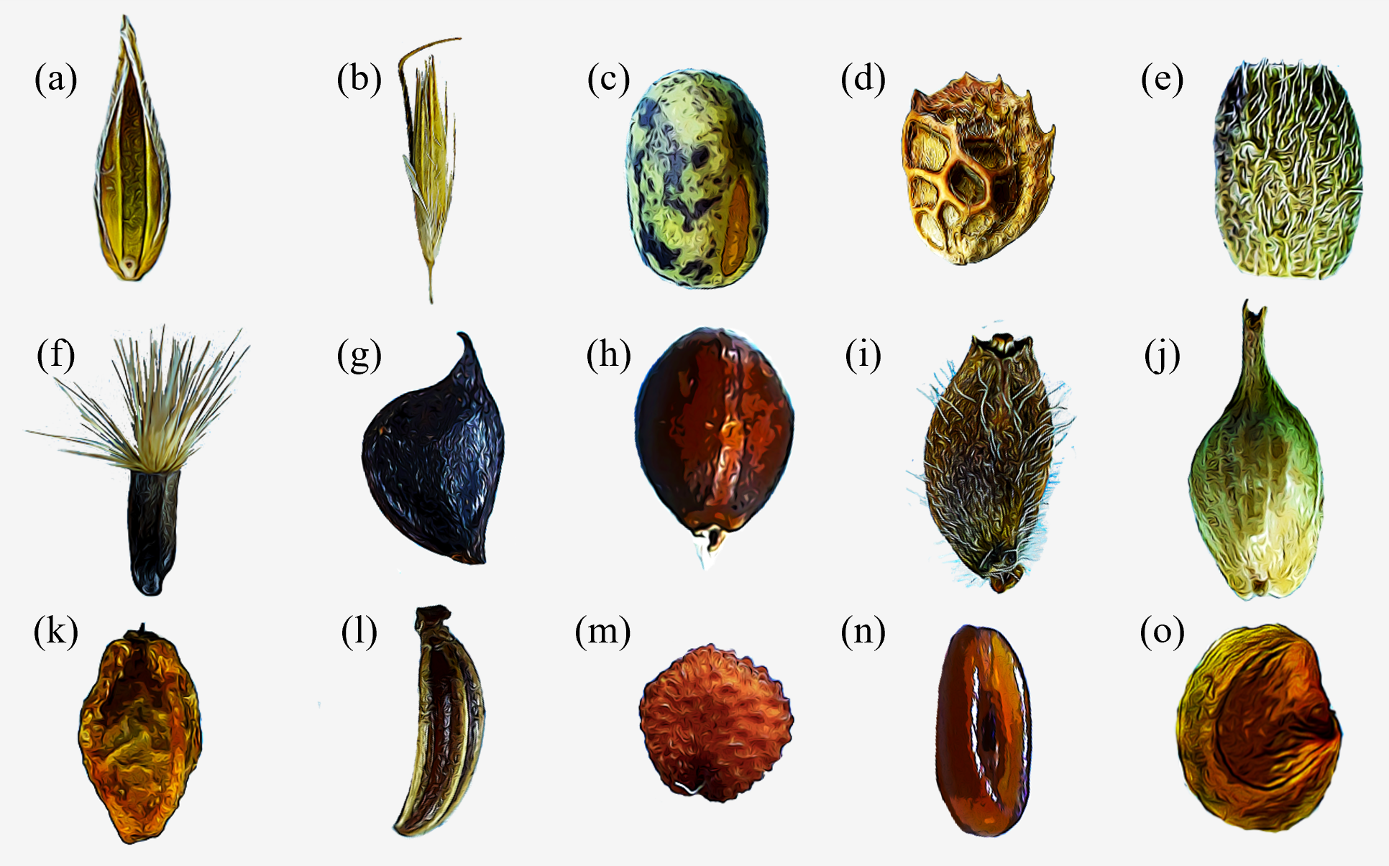

Figure 1: Diversity of dispersal units in plant species from mesic meadows: (a) Floret of *Cynosurus cristatus* (Poaceae); (b) floret of *Arrhenatherum elatius* (Poaceae); (c) seed of *Lathyrus pratensis* (Fabaceae); (d) legume of *Onobrychis viciifolia* (Fabaceae); (e) loment fragment of *Ornithopus perpusillus* (Fabaceae); (f) achene with pappus of *Centaurea scabiosa* (Asteraceae); (g) achene of *Ranunculus acris* (Ranunculaceae); (h) nutlet of *Prunella grandiflora* (Lamiaceae); (i) achene of *Knautia nevadensis* (Dipsacaceae); (j) perigynium of *Carex binervis* (Cyperaceae); (k) receptacle of *Sanguisorba minor* (Rosaceae); (l) mericarp of *Carum verticillatum* (Apiaceae); (m) seed of *Cerastium fontanum* (Caryophyllaceae); (n) seed of *Plantago lanceolata* (Plantaginaceae); (o) seed of *Rhinanthus angustifolius* (Orobanchaceae).

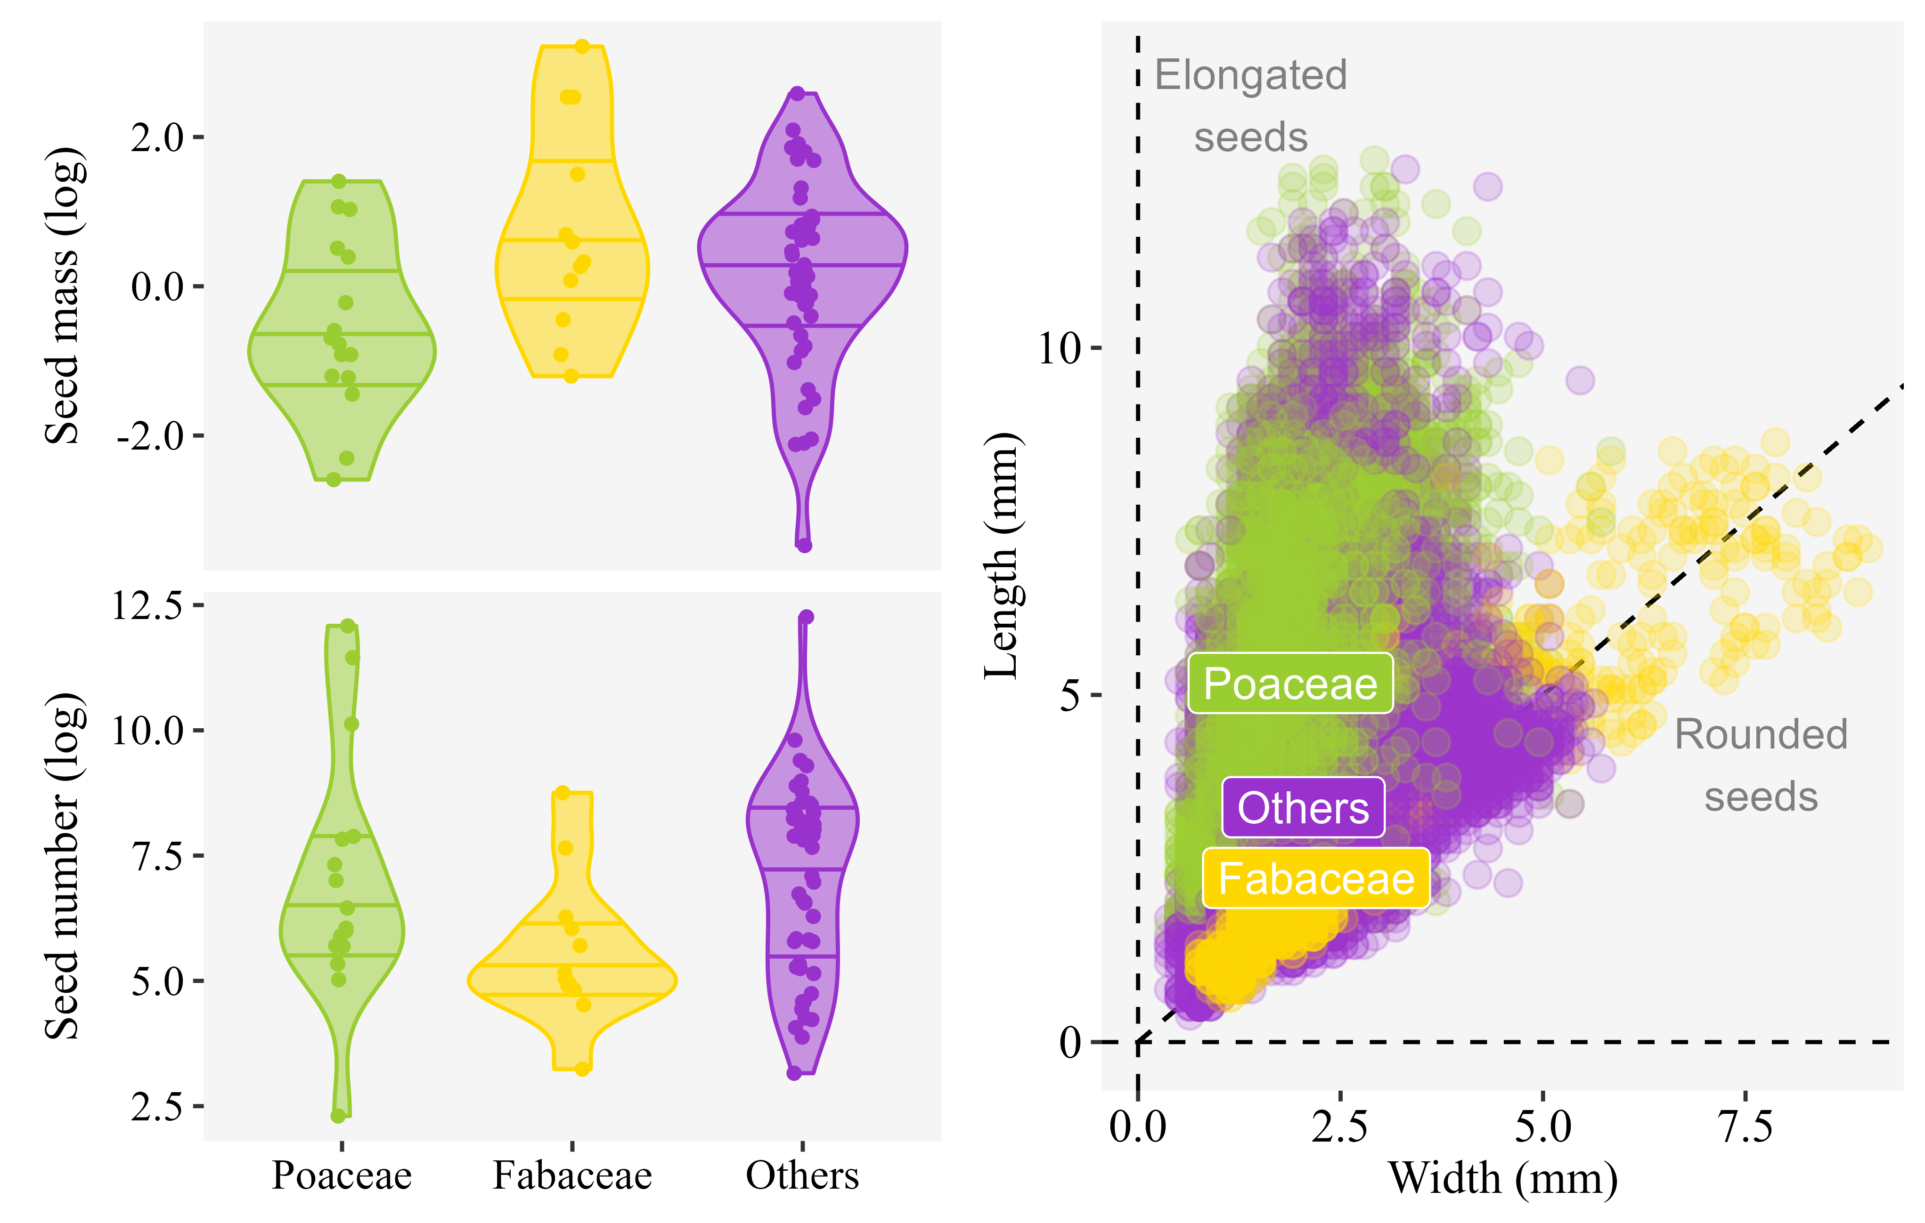

Figure 2: Morphology of mesic meadow seeds. The two panels on the left show the probability densities of species values for seed mass and seed number, log-transformed for ease of visualization. The three horizontal lines within the probability densities represent the first quartile, the median and the third quartile of the values. The panel on the right shows values of seed length and width obtained by image analysis, with each point being a seed. In all cases, data is divided between the grasses (Poaceae), legumes (Fabaceae) and the other plant families.

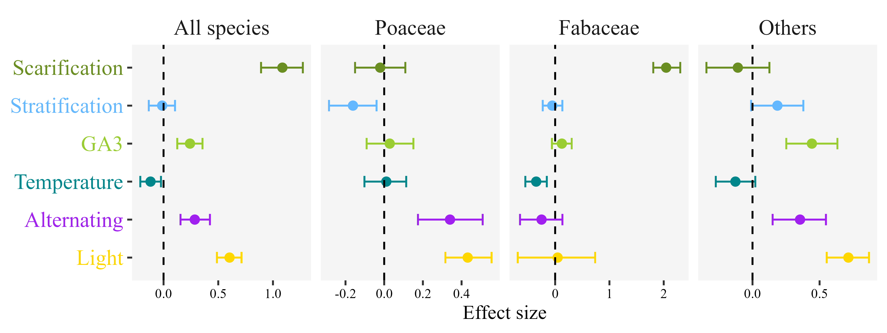

Figure 3: Germination cues in mesic meadows. Effect of germination cues simulated in the laboratory over the final germination proportions of mesic meadow seeds. Dots indicate the posterior mean of the effect size for each cue, and whiskers the 95% credible interval of the effect size. The line of zero-effect is shown: when a credible interval overlaps with the zero-effect line, the effect can be regarded as non-significant. In separate panels, the figure shows the results of a general model including data for all species, plus specific models for the three main botanical groups of mesic meadows: grasses (Poaceae), legumes (Fabaceae) and the other families.

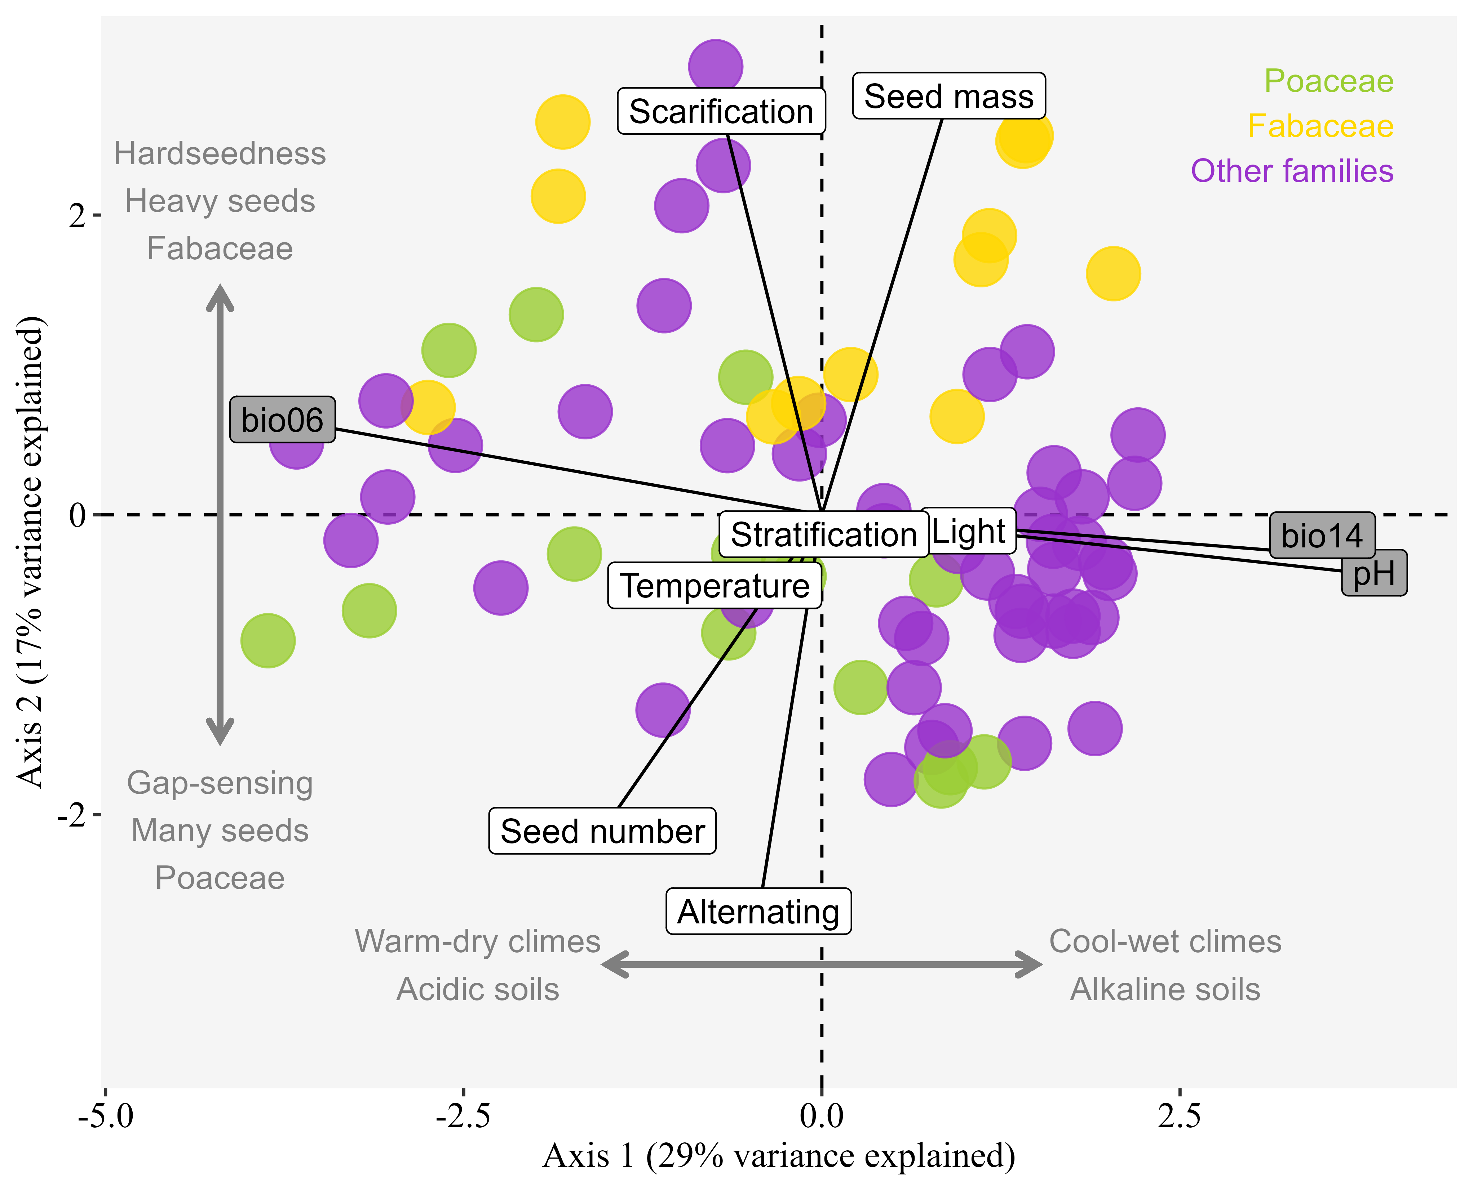

Figure 4: Environment and seed traits are separate axis of variation in mesic meadows. Principal Component Analysis ordination of mesic meadow species considering their environmental preferences and their seed traits. Each point is a species, coloured by the three main botanical groups of mesic meadows: grasses (Poaceae), legumes (Fabaceae) and the other families. Labels indicate the contribution of the variables to the axes: grey-background labels for environmental preferences, and white-background labels for seed traits. Environmental preferences were calculated as species niche centroids (SNCs) for the minimal temperature of the coldest month (bio06), precipitation of the driest month (bio14), and soil pH. To calculate the SNCs, a vegetation dataset of mesic meadows of the Iberian Peninsula was used. The seed traits are seed mass and the germination relative indices for the response to scarification, stratification, average germination temperature (temperature), alternating temperature (alternating) and light. All environmental preferences aligned to the first axis, while seed traits aligned to the second axis, showing that environment and seed traits are separate axis of variation in mesic meadows. Stratification and average germination temperature showed very low variation, in accordance with their small effect on Figure 2.

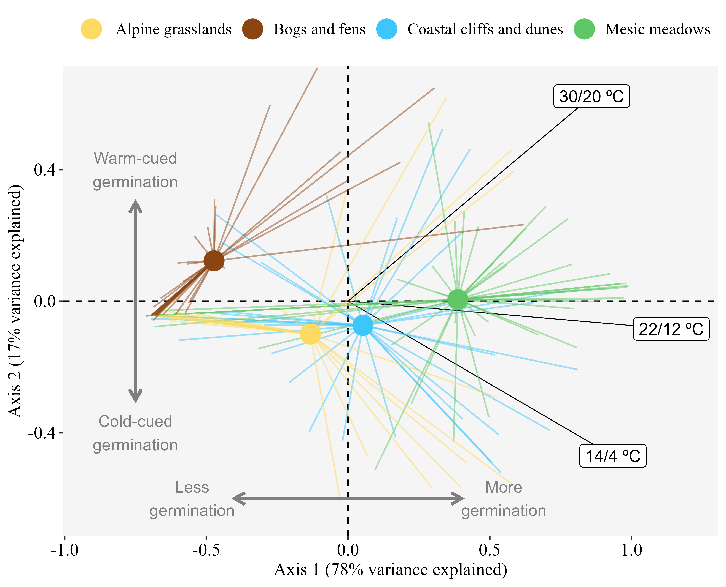

Figure 5: Higher germinability in mesic meadows compared to other herbaceous plant communities. Principal Component Analysis ordination of species responses to three seed germination treatments (fresh seeds germinated at 30/20, 22/12 and 14/4 ºC in a 12/12h light-darkness photoperiod). Species are grouped by their habitat, with points showing the centroid for each habitat group, and rays linking the centroid with the position of each species in the group. Labels indicate the contribution of the germination treatments to the axes. All species had been collected in herbaceous vegetation types of the Cantabrian Mountains of Spain and the neighbouring coast. All seeds were untreated, except for scarification, which was applied routinely to all botanical families presenting physical dormancy. Germination treatments consisted in 12/12 h periods with a warmer phase in light and a cooler phase in darkness. The position of mesic meadows compared to the other habitats indicates that their species tended to have higher germinability even if untreated (i.e. less seed dormancy) and were more neutral in their thermal requirements.